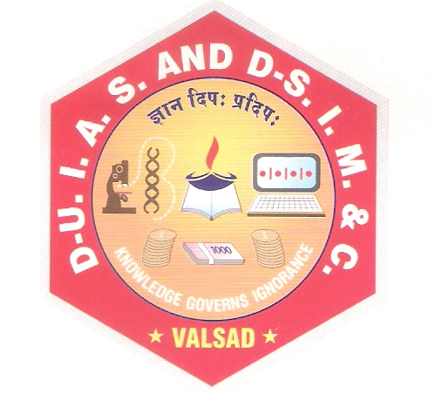
Computer Science and Application Department

CERTIFICATE

This is to certify that the project work is satisfactorily carried out on Online cruise booking system is a work done by Ms.Kanuga mushira abdulsaid in partial fulfillment of the requirement for the award of the degree of bachelor of computer applications during the academic year 2025 -2026.I appreciate their hard work, honesty and discipline during the training for concerned project in our organization. The project work was carried out under our supervision and guidance of internal guide.

__________________ ___________________
Dr. Premal Shah Dr. Snehal Joshi
Project Internal Guide I / C Principal and HOD

Project Certified Date: _____________
At T.Y.B.C.A Examination
Examiners:
1. ________________
2. ________________

